**Lab: S3 Enable Versioning**

**Services Used: S3**

1. Go to S3 Service in AWS Dashboard.
2. Select the bucket for which you are enabling Versioning. [ Note versioning can be enabled during bucket creation also]
3. In this lab we are enabling it on demo-2019 bucket.

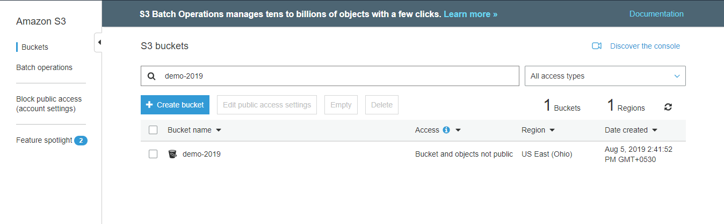

1. Click the bucket and select the bucket properties. Currently the versioning is disabled and we are going to enable it.

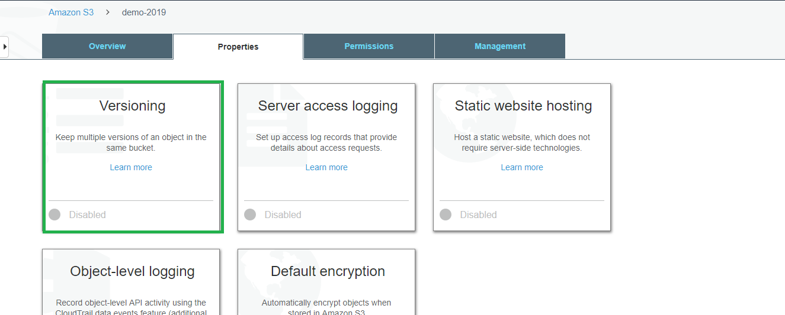

1. Select Versioning enable versioning and save the settings.

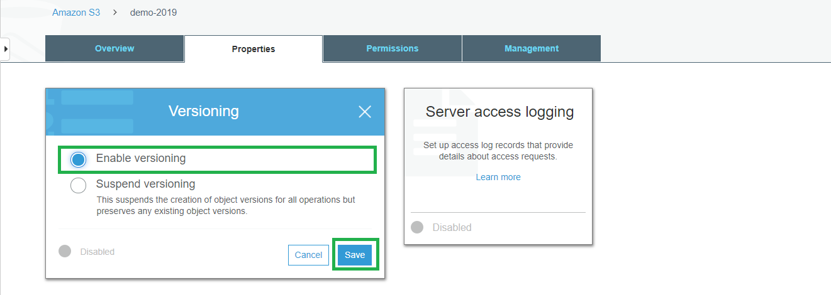

1. Now the versioning is enabled on the bucket.

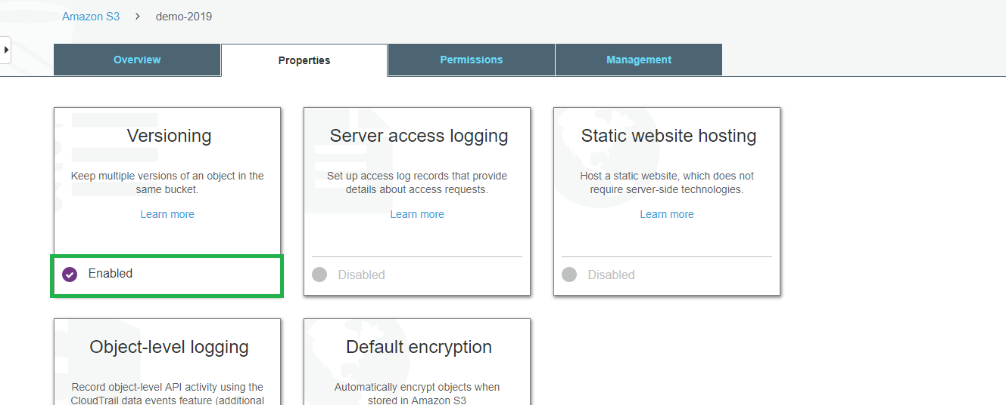

1. Now we can see versions tab is enabled with hide and show buttons. If we select show button we can list all the versions available for the objects in the bucket.

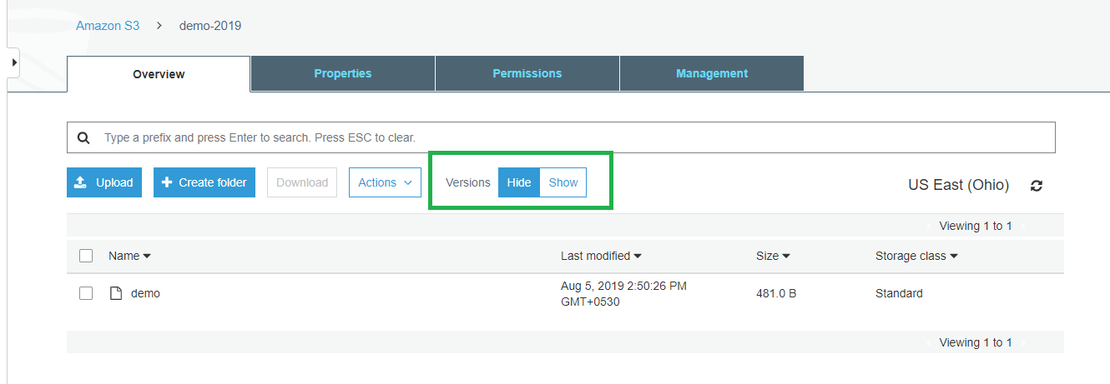

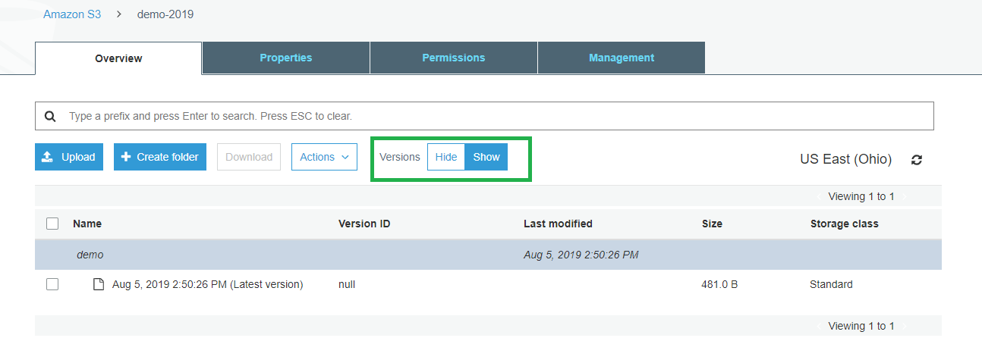

1. We are not uploading a new file S3 versioning.txt with below text.

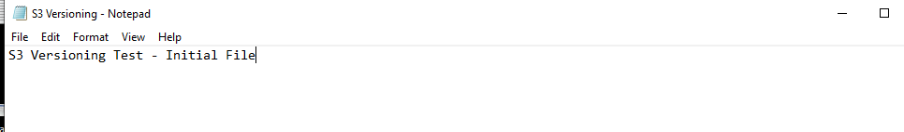

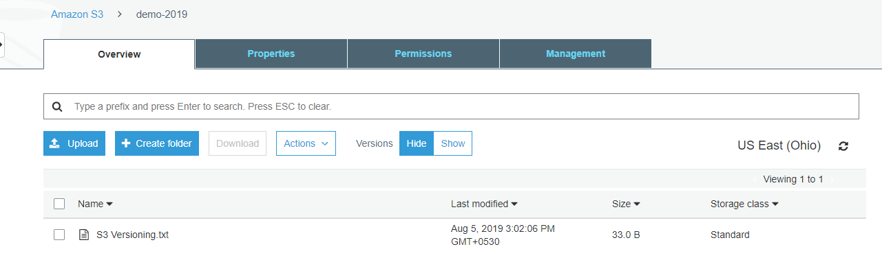

1. As versioning is enabled this file gets a unique version id.

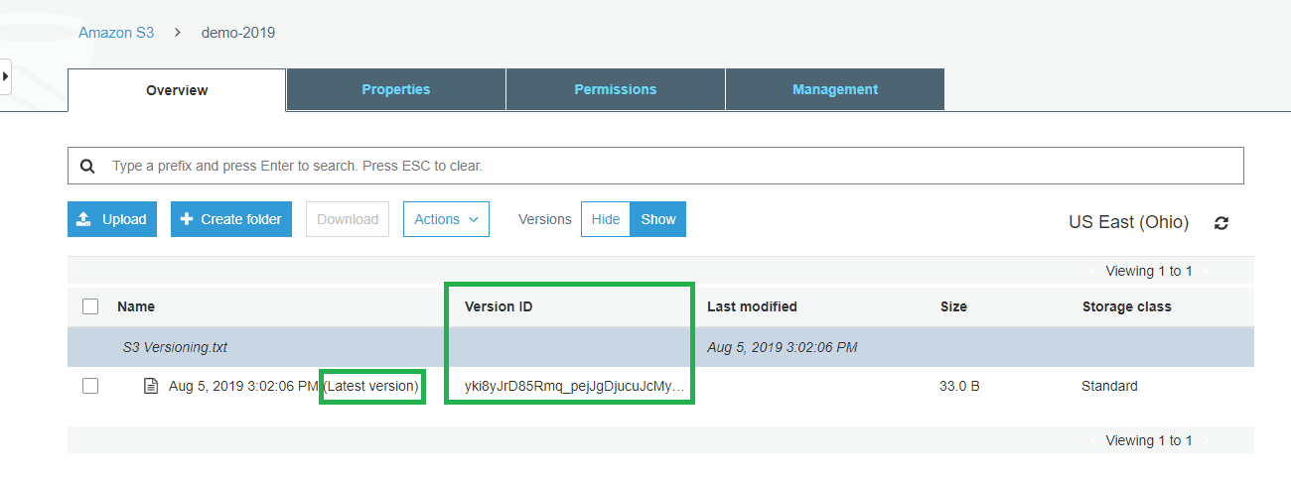

1. Now we are updating the same file with new data and reuploading.

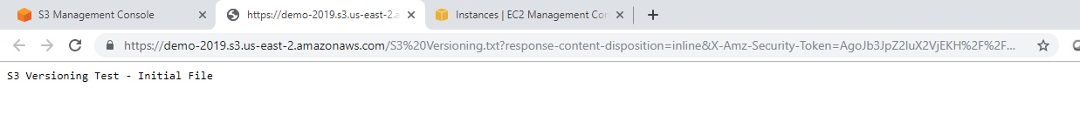

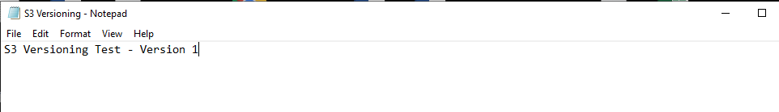

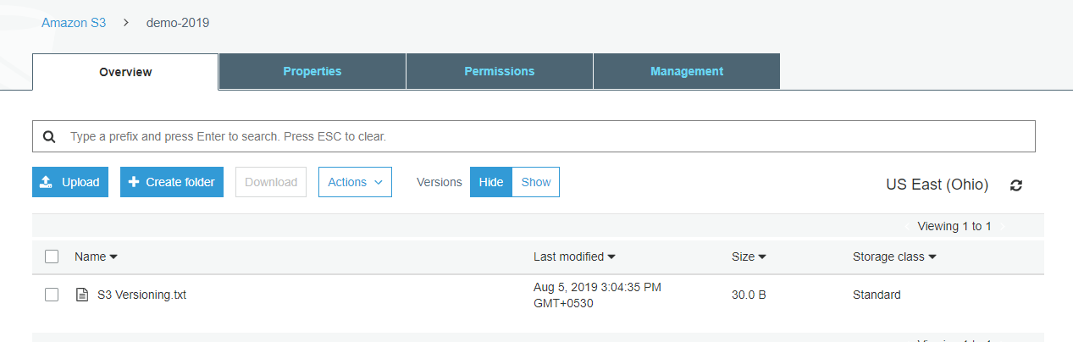

1. The file now gets new version id which is the latest version as well.

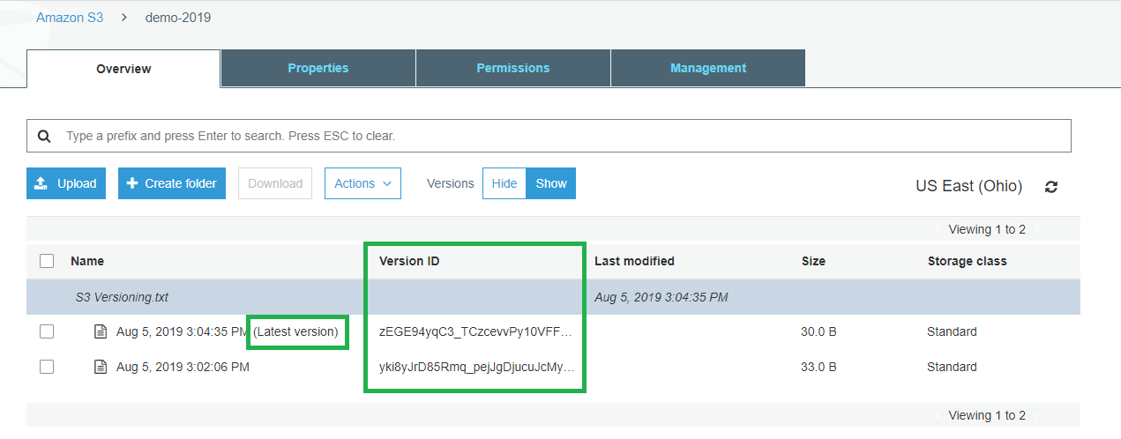

1. With versioning enabled the file default opens the latest version. However you can still download the previous versions in case if your latest version is corrupted or to be restored.

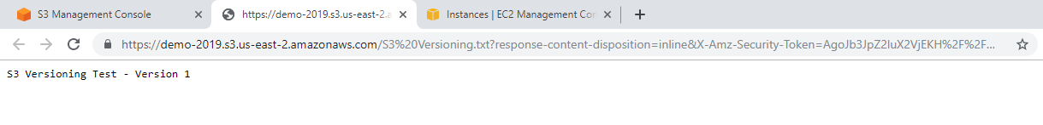

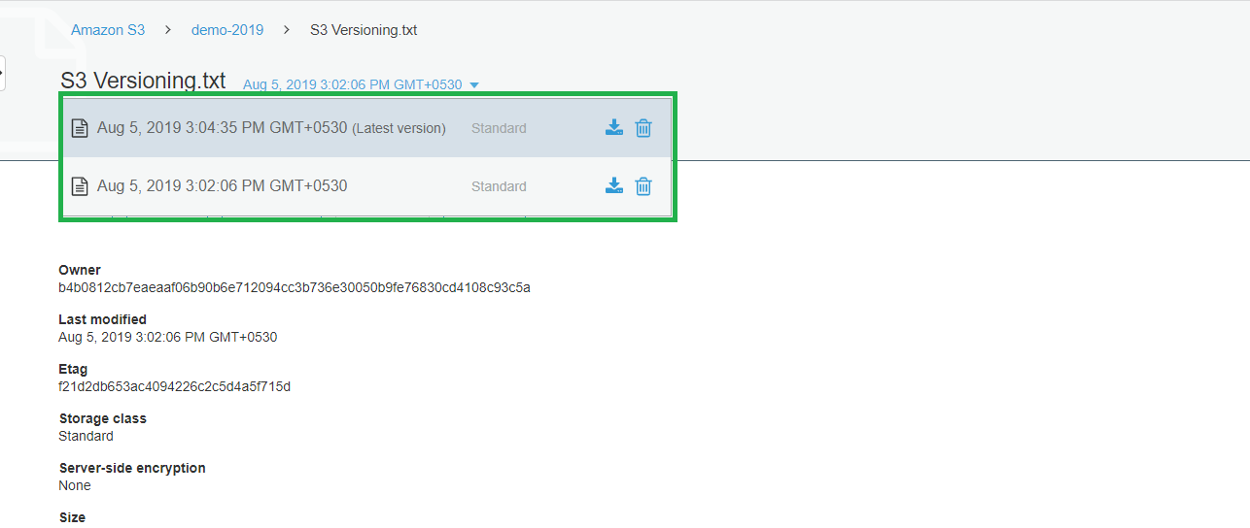

1. You can delete the individual versions if you no more needed using below procedure.

